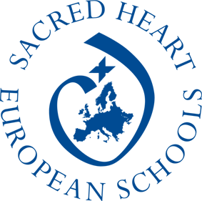
European Identity and Values
in the Lives of Young People

Four European schools have joined to implement this Erasmus+ project: Gymnasium Sacré Coeur Wien, Sagrado Corazón de Jesús, Placeres, Pontevedra, Tartu Descartes'i Kooli (Estonia) and La Perverie Sacré Cœur, Nantes.
It has generated a lot of interest among the teachers and a lot of students are taking part, getting really involved in its implementation. They meet regularly to prepare future meetings and debates on European values, in the process improving their knowledge and skills. Our schools are very open to international projects, it is part of our fundamental values: in our multicultural world we wish to prepare and inspire our students to be active, informed and responsible global citizens.
The opening meeting took place in Nantes (France) and was extremely beneficial to all groups. It allowed us to explain carefully the issues involved in our project. Materials had been put on a web platform in advance so that all students could prepare and become informed about our European historical, geographical, political, religious, and economic identity.
The 2nd meeting took place in Tartu (Estonia), what a rich moment for all partners! We received such a warm welcome! Two main workshops had been set up: an auction to bid for European values and a roleplay session acting as members of the European Parliament. The enthusiasm for these activities was exceptional.
The four partners communicate well and get along brilliantly. The adults involved have very good English which allows very constructive and unambiguous exchanges. Cooperation is strong.
In our opinion, halfway through our project has reached its main goals in so far as our students have become particularly aware of identity issues in Europe. They are also developing a lot of language skills in English!
Next meetings: Spain (Placeres) in October 2019 and Austria (Vienna) in May 2020.
