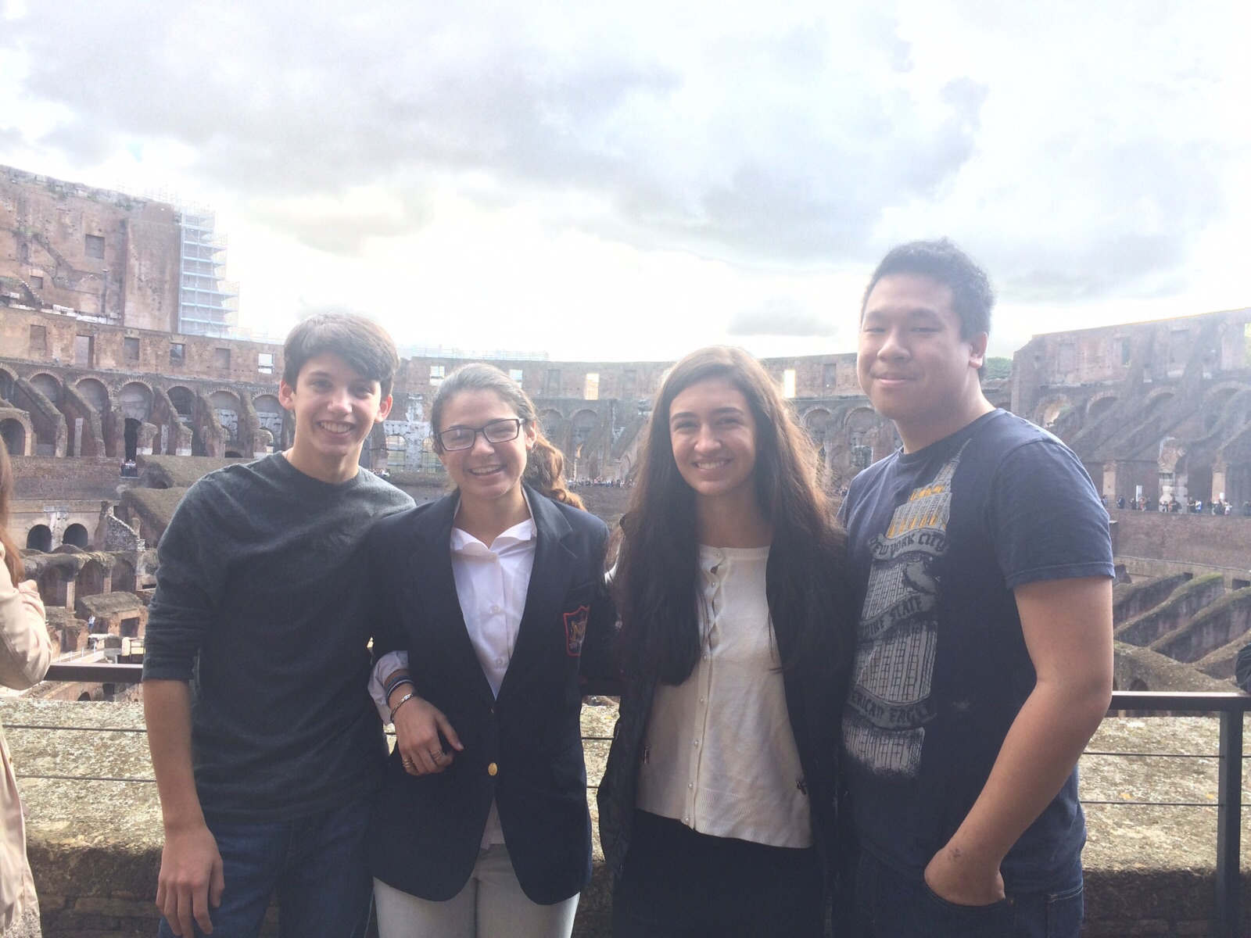

The USA at our school!
From the American life to the Italian style

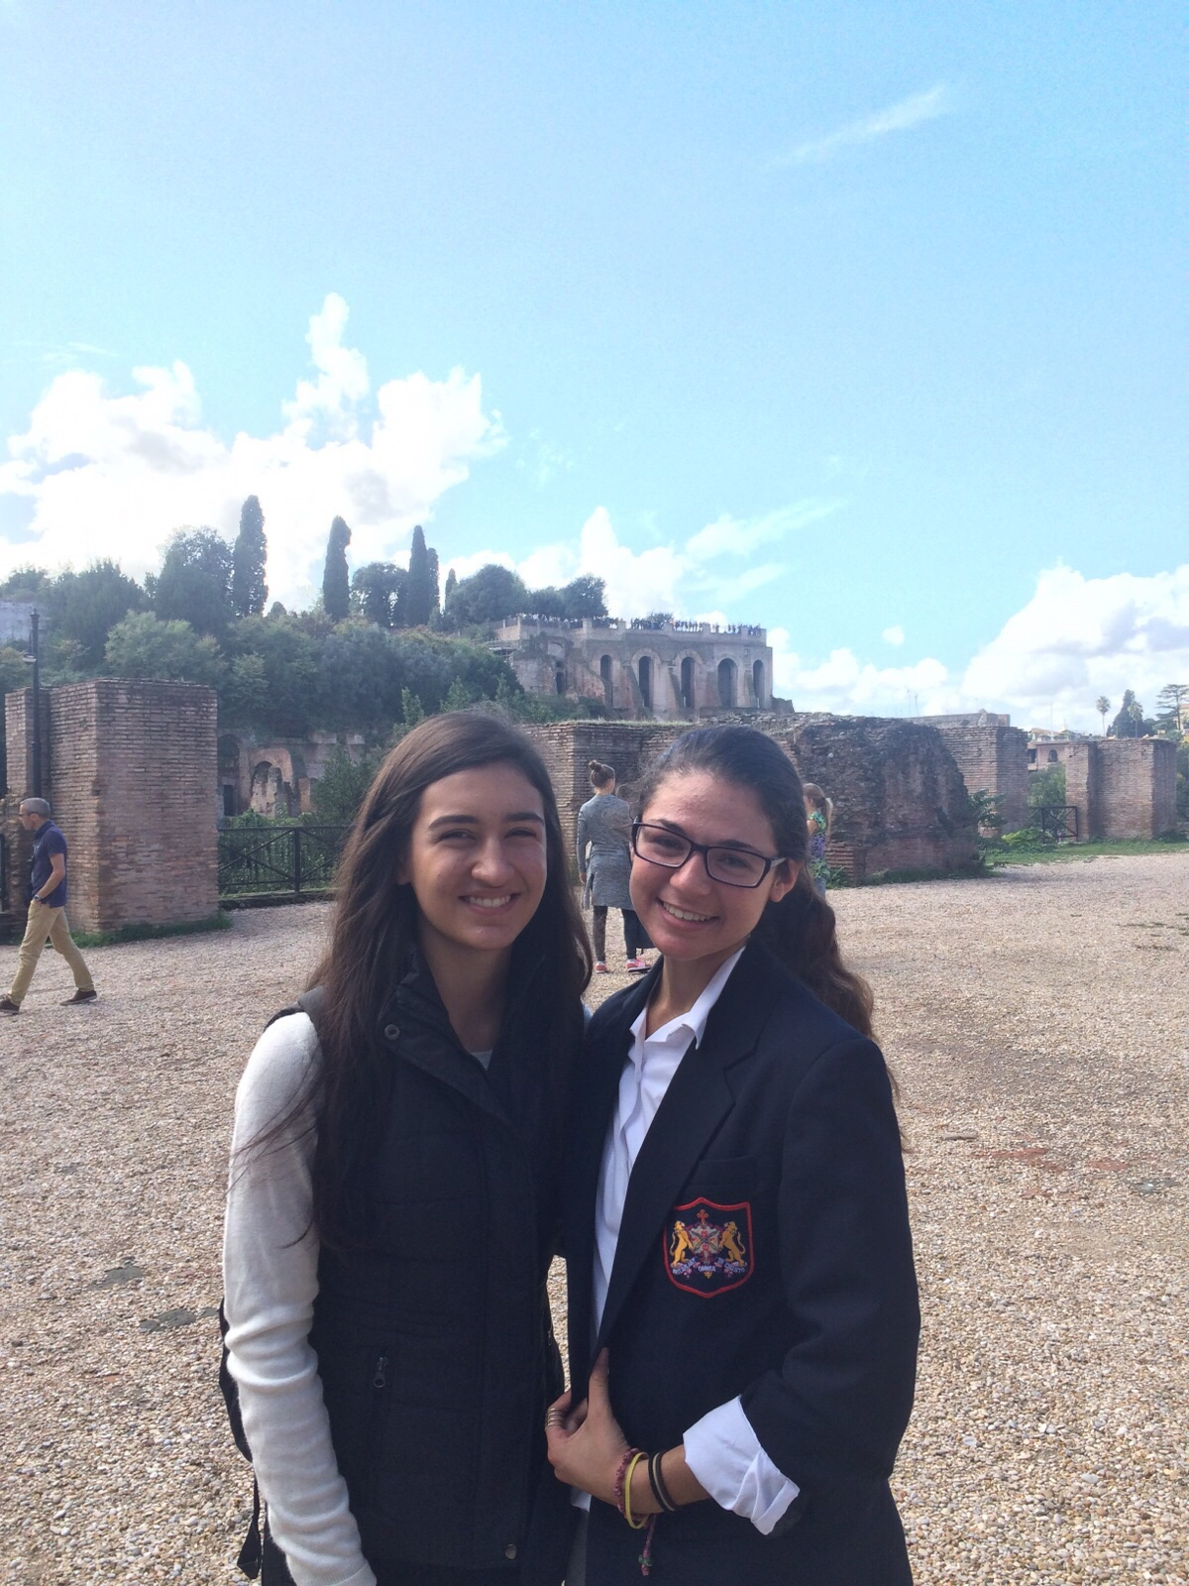
Exhausted and tired, four students from the Monfort Academy in New York, USA, made it through an eight-hour flight to reach our beloved city, Rome, with their school president Mr. Richard Greco. Having refreshed at the Hotel Parco dei Principi, they had a small appetizer at seven o’clock with their Italian correspondents Alice Costanzi Fantini, Giulia Caffarelli, Pier Francesco Berto, and Valerio Ulivieri. Mr. Greco and Mrs. Zanetti offered the wonderful time in the luxurious hotel where Mary Greco, Catherine Rex, Chris Chan, and Joe Petrillo had the chance to meet with their host families. Later, they all had dinner in a famous restaurant in the heart of Rome called San Marco.
After a pizza, various plates of spaghetti and gelato, they joined their respective families and headed home. A tough month was ahead of them; school, visits around the city, and lots of shopping exploring the historic city everyday, living like real Italians! Since their school offers Italian courses, they came here knowing a few words and were almost entirely independent conversing with other people. Feeling a little jet-lagged, they made it through the first week and slowly got used to the rhythm improving their Italian at school thanks to the incredible support of professoressa Loredana De Santis. She patiently guided them throughout the tricky language and helped them speak it better, in hope they can return home dominating this culture.

