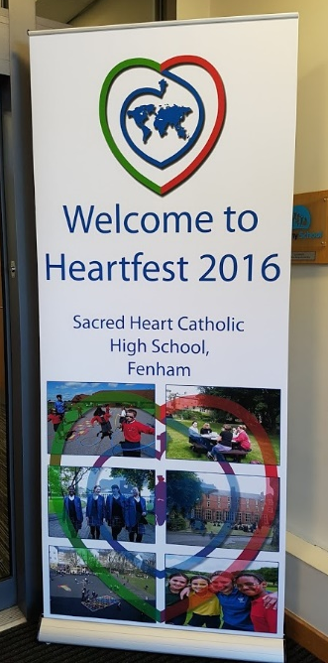
HEART FEST!!!
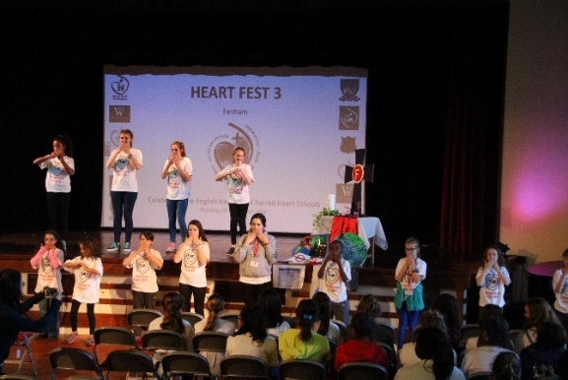
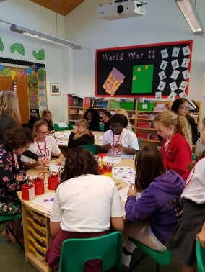
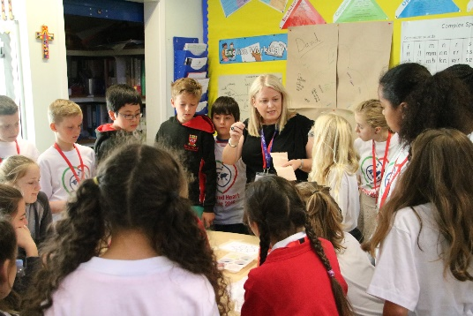
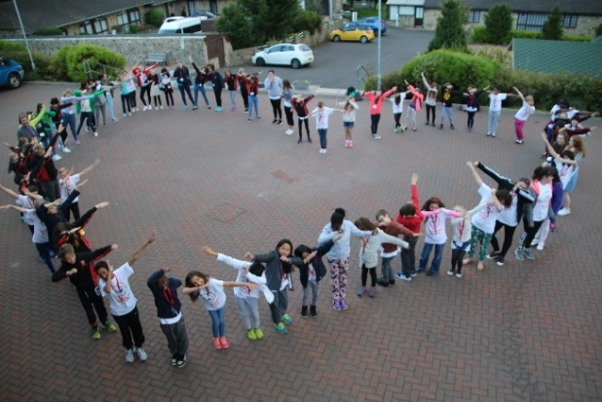
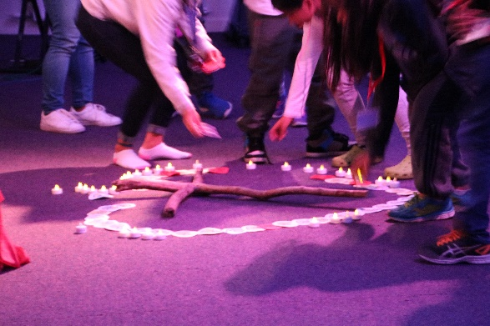
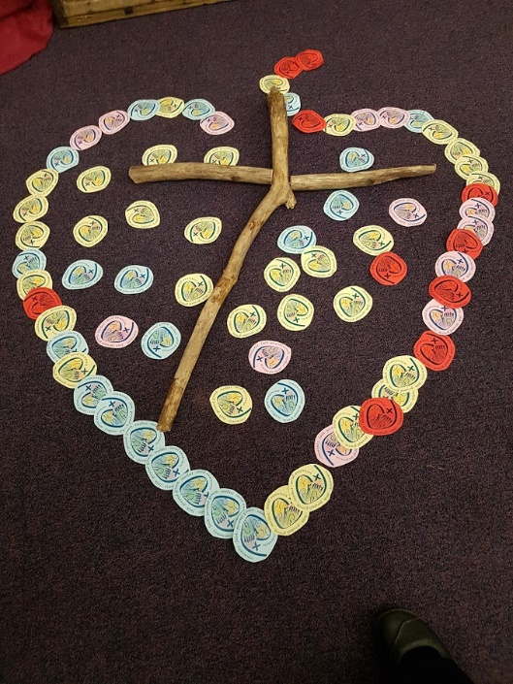
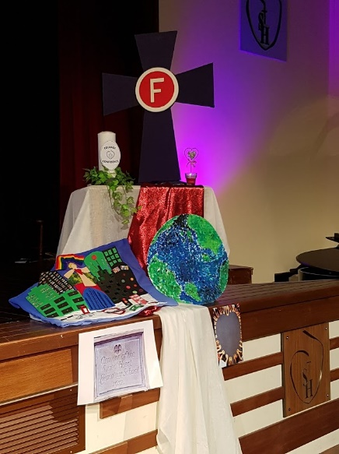
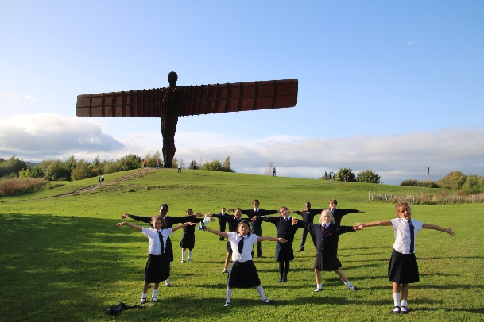
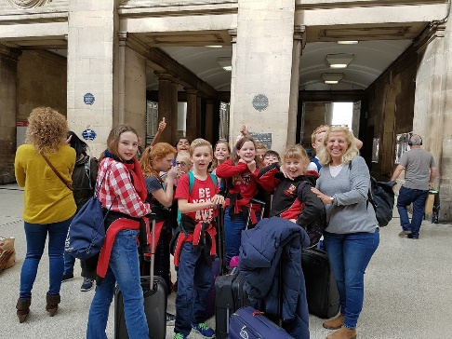
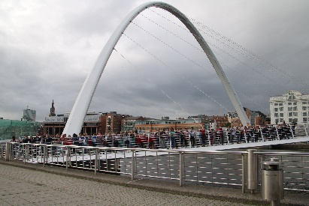
In September 2016 around 80 students and staff from our English Network of Sacred Heart Schools came together in Newcastle for 3 days of activities and prayer. There was great excitement all round, some tourism, a really warm welcome from our hosts and a wonderful liturgy. We were really pleased that several of the local and not so local RSCJ were able to join us. Our theme was based around the Goal of Intellect which is our focus this year. In the evening in the local diocesan Youth Village we reflected on the words from the letter to Timothy, “For God has not given us a spirit of fear and timidity, but of power, love, and self-discipline.” During prayer the young people (and us older ones) wrote a prayer asking for God's help to overcome a fear they (we) had. We then went up group by group to take a candle from the heart (see photo) and replace it with their prayer, written on the back of our new Goals' Logo. These were placed in the shape of the open Heart of Jesus. It was very moving.

