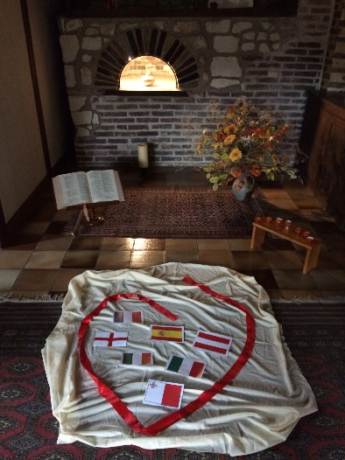
Feeling at home in the house of Sophie!
March 2016

Twenty one of us arrived in Joigny in early March for our fourth European Sacred Heart Educators’ session in Sophie’s home.

Our group relaxed quickly, welcomed warmly by the community and inspired by the familiar story told “sur place” as well as the talks by Maryvonne Keraly RSCJ and Patricia Garcia de Quevedo RSCJ. The sun came out for our walk in the vineyards where both Chantal de Jonghe RSCJ, and the vineyard worker pruning the vines, brought John 15 alive for us. Participants valued so much the exchange, space and ambiance, gaining a deeper understanding of the internationality which is the Society’s gift to our schools and the spirituality of the Sacred Heart.

We were blessed with wonderful translators, Mary Shiel RSCJ from Ireland, then Carolina and Natalia, two teachers from Spain. They all shared their skill, joy and humour with us! Mary helped us prepare a mass which really celebrated our different languages: Maltese, Italian and German as well as the English, French and Spanish which we used for most of the time together.
A group of us continued in Sophie’s footsteps in Paris, visiting the Rue Varennes reflecting on the challenges she faced and finally spending a moment in prayer near her in St François Xavier’s Church.
We had a very happy time together and all went home with fresh energy and motivation!

